TASKS ON EC2 (Elastic CloudComputing)

1. Launch one EC2 using Amazon Linux 2 image and add a script in user data to install Apache.
OBJECTIVE: To launch an instance of amazon linux image and install apache by writing a script in user data.
STEP BY STEP IMPLEMENTATION:
- Create an instance with amazon linux image & add a pem key to that instance and select the existing security group i.e.. default security group.

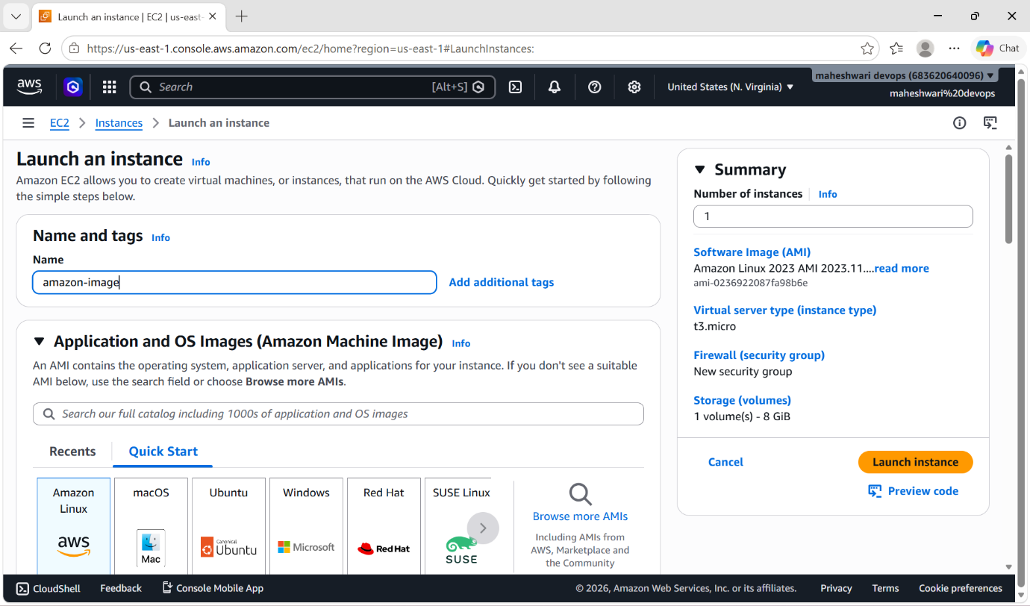

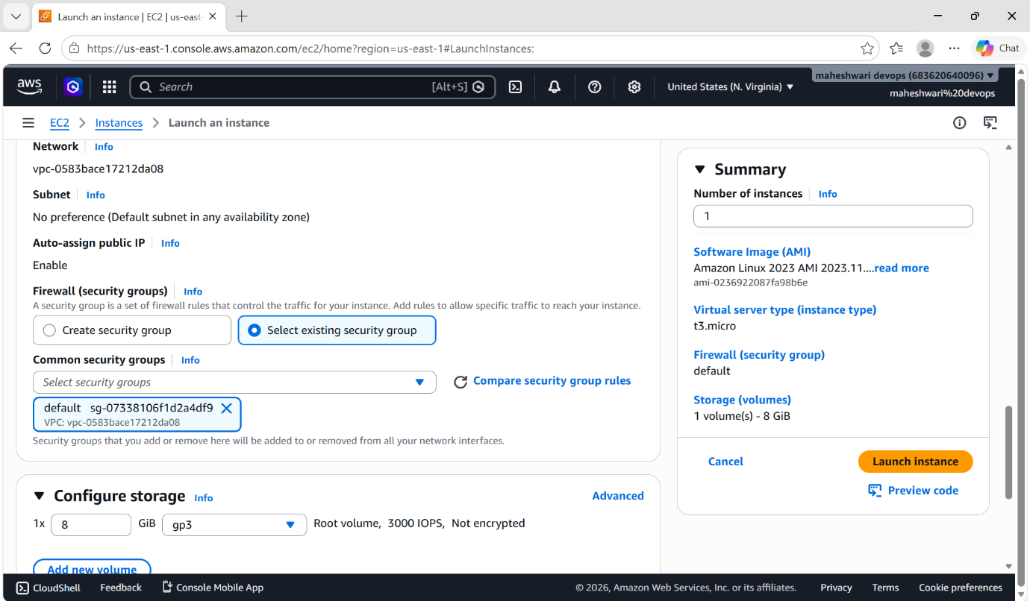

- Then add the required steps to install a apache service in the user data.
#!/bin/bash
Sudo update -y
Sudo yum install httpd -y
systemctl start httpd
systemctl enable httpd
echo “SUCCESSFULLY INSTALLED HTTPD ON AMAZON LINUX IMAGE SERVER” > /var/www/httpd/index.html

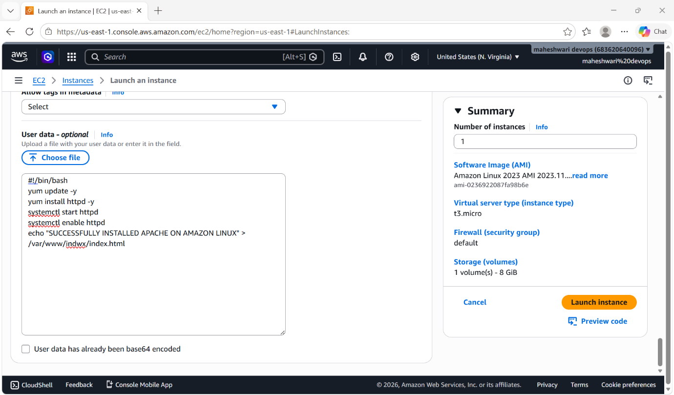

- Then login into git bash by using command ->
ssh -i file.pem ec2-user@public-ip

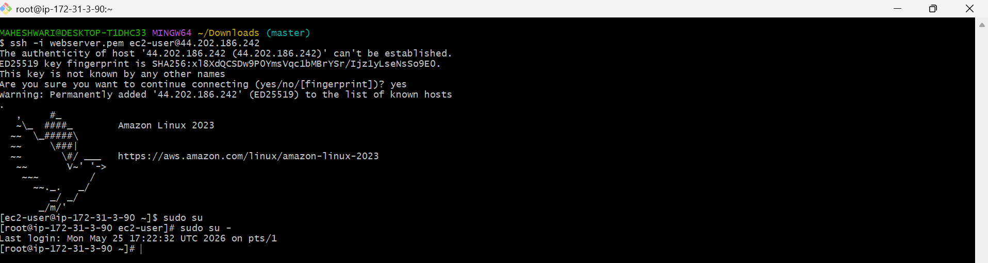

- Then check for the status of our service that we have installed at the time of launching instance
systemctl status httpd
- Verify the service with the default port number and public ip of our instance
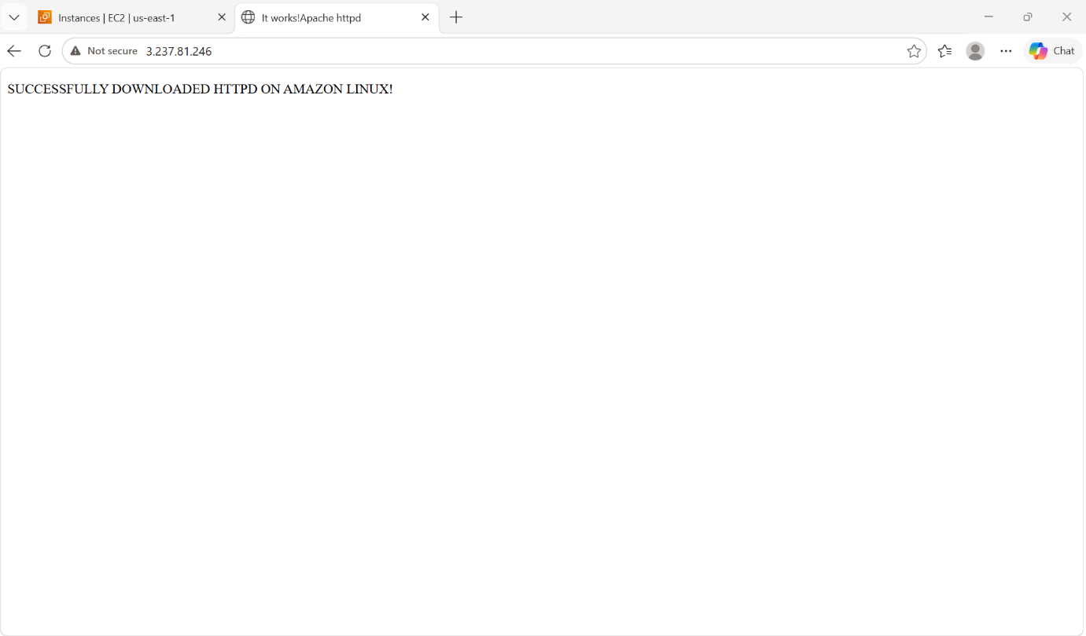

2. Launch one EC2 using Ubuntu image and add a script in user data to install Nginx.
OBJECTIVE: to launch an instance of ubuntu image and install nginx service by using user data
STEP BY STEP IMPLEMENTATION:
- Launch an instance with the ubuntu image and select the free tier image
- Then add a key-pair to for the access to ssh login
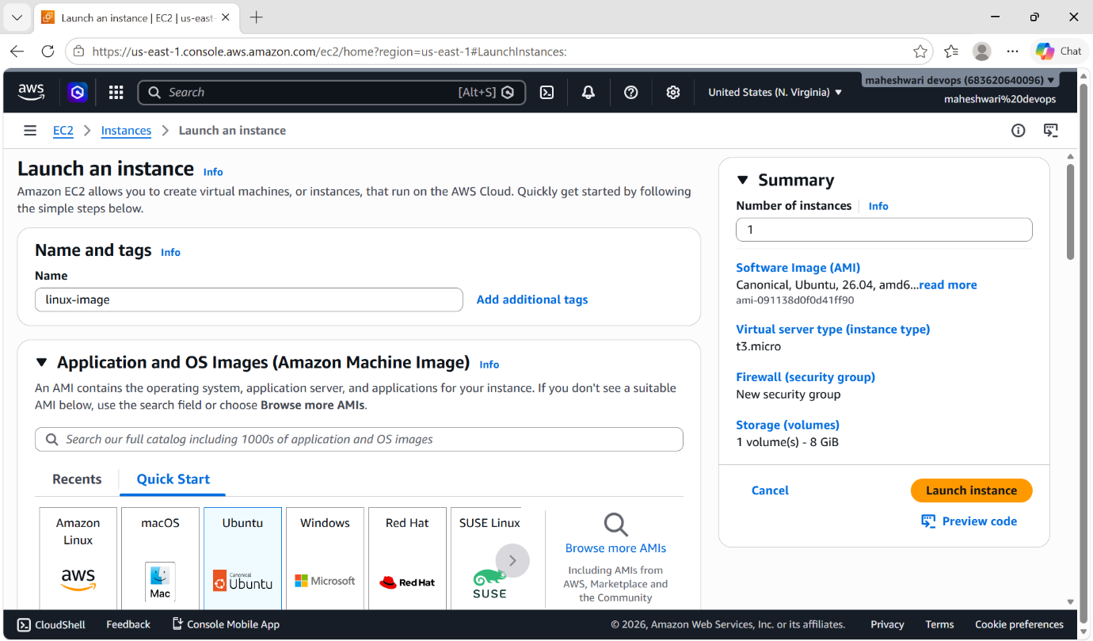
- select existing security groups with the inbound rules and outbound rules
- write a script to install nginx in ubuntu service in the user data

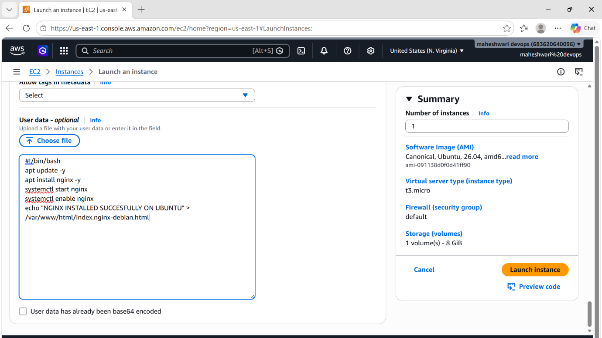

- then connect with git by using ssh command
- ssh -i pem.file ubuntu@public-ip
- then check for the status of the downloaded service while launching the instance -> systemctl status nginx
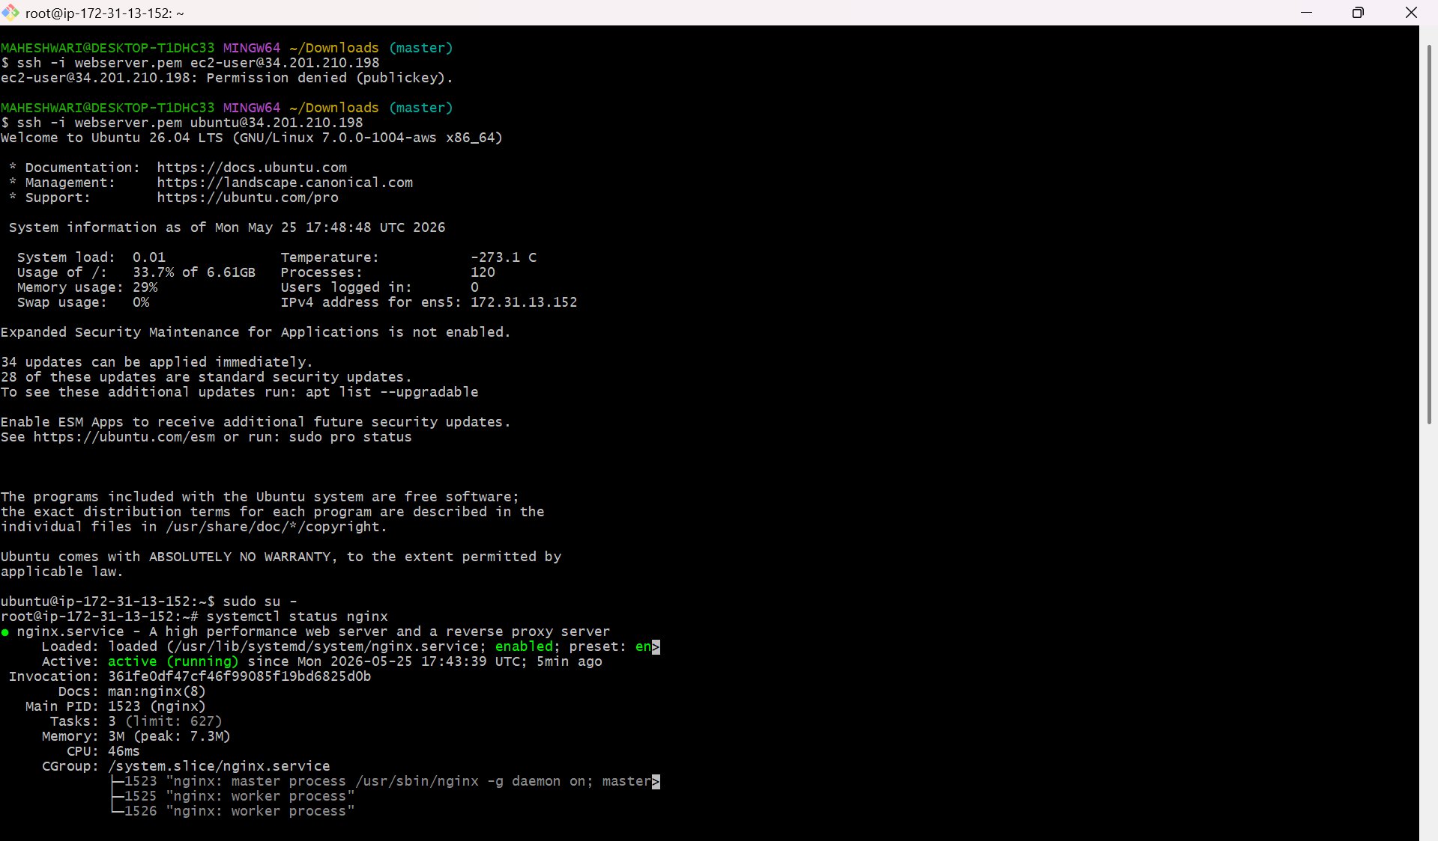

- to verify that our service is running on the given port the check for the localhost:80 or public-ip:80

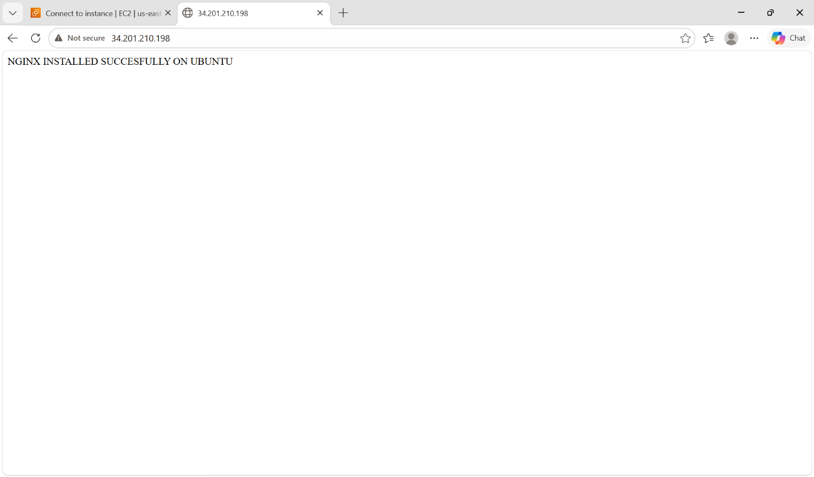

3. Launch one Windows server and install Tomcat on Windows.
OBJECTIVE: To launch an instance of windows image and install tomcat on that remote computer instance that we have launched.

STEP BY STEP IMPLEMENTATION:
- create a instance on aws by selecting a Microsoft image and the selected image is free tier.
- Create a key pair that is used to connect with the remote computer.

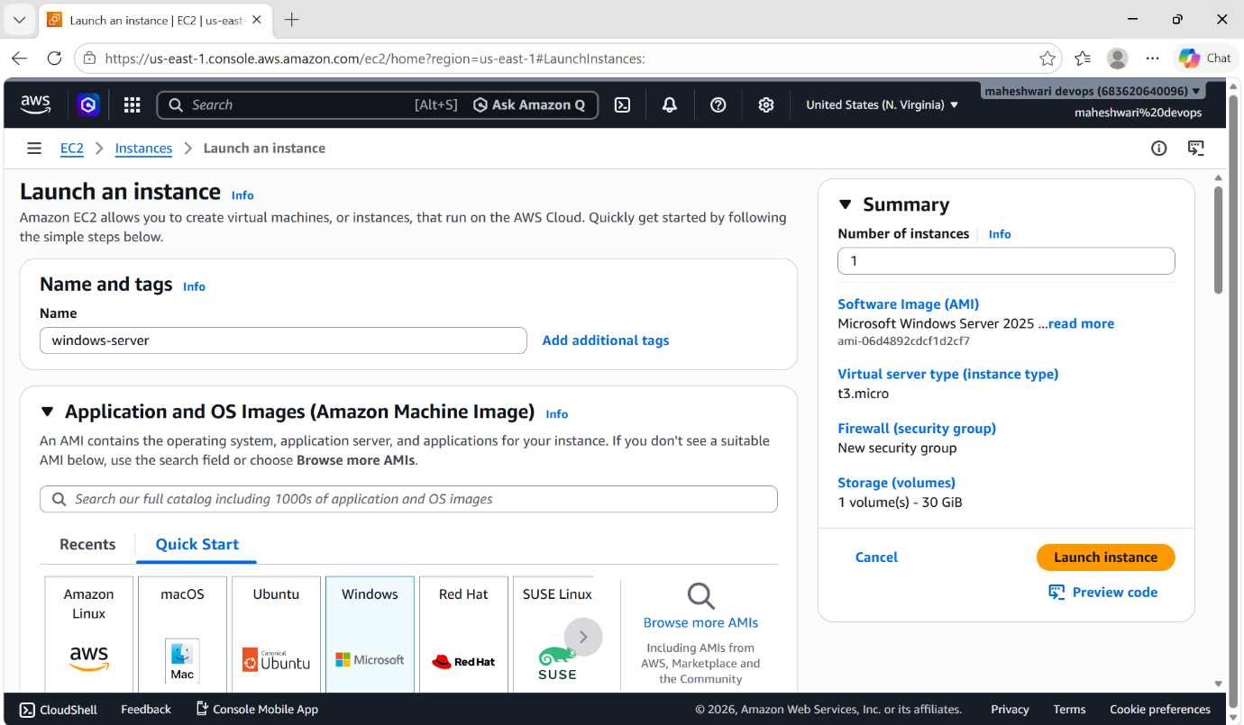

- After launching that instance, search for the desktop remote connection to connect with that created instance.
- For this, search for the desktop remote connection in our local machine.

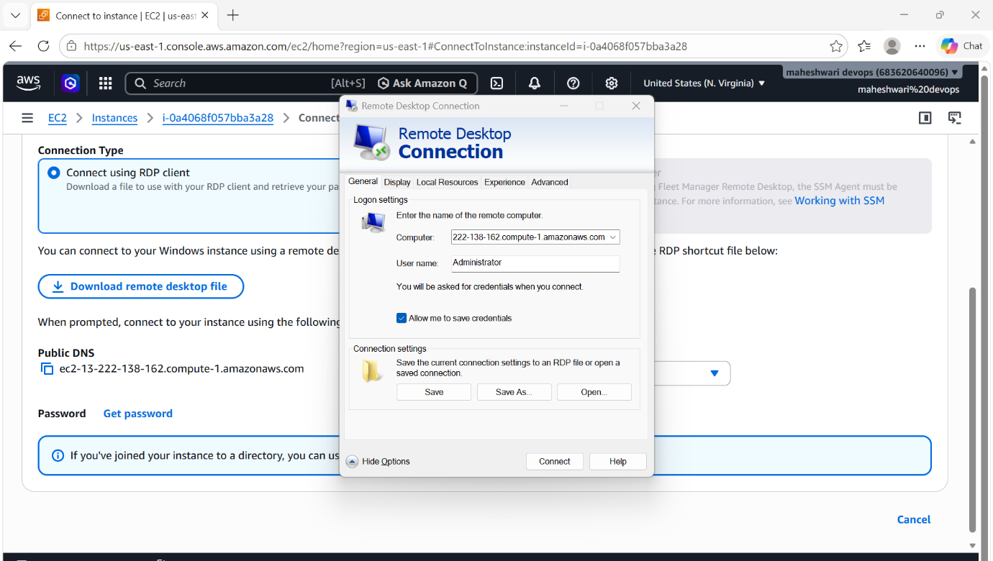

- Here, we have to give the computer name that is available in our created instance -> ec2-13-222-138-162.compute-1.amazonaws.com
- Then will give the user name -> administrator
- Then we have to give the password, to get that password click on get password then it will ask for the .pem file key
- Copy that key content and paste it here, it will decrypt that key and give the password for.
- Then copy that dycrypted key, use that key to connect with remote desktop.

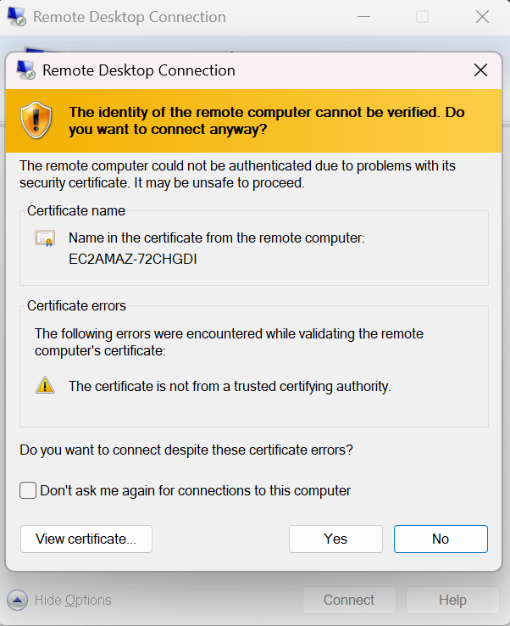

- By this process, we will able to connect with remote desktop.
- To install tomcat, java is the prerequisite for the tomcat. So download java from the browser.
- After downloading java, download tomcat from the browser.
- Then go to command prompt of that remote computer.
- First of all, search for the java path -> where java
- After getting that path of java, copy that path and set that path for tomcat identification
- By using set command, we can set the path of the java for temporary -> set JAVA_HOME=”path”
- Then extract the downloaded zip file of tomcat by right clicking the click on extract all.
- Now the extracted file will available and it will be used to start the tomcat service in the browser.
- Use the command to start the tomcat service -> startup.bat.

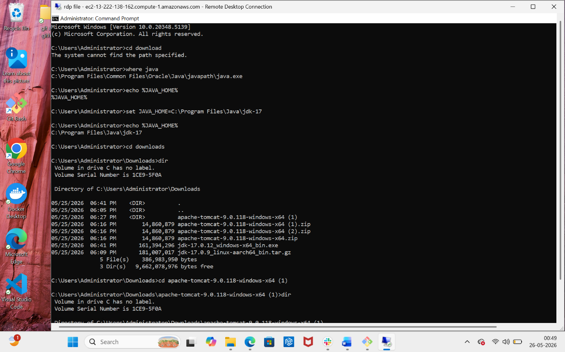

- To verify that tomcat service is running or not, use the command -> netstat -ano | findstr 8080



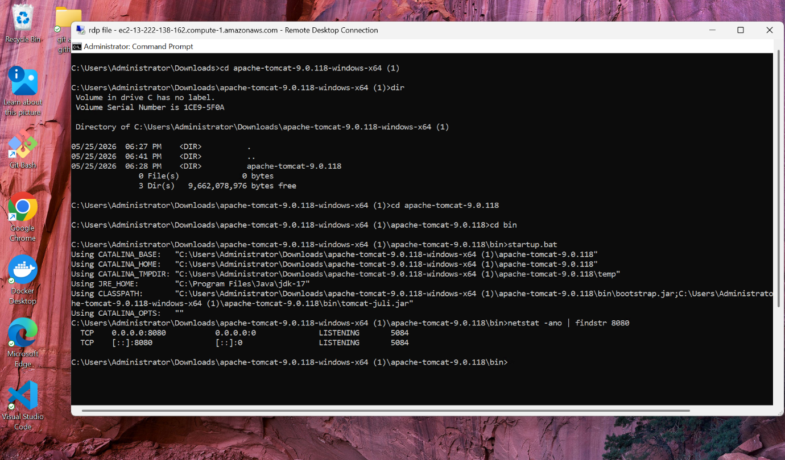

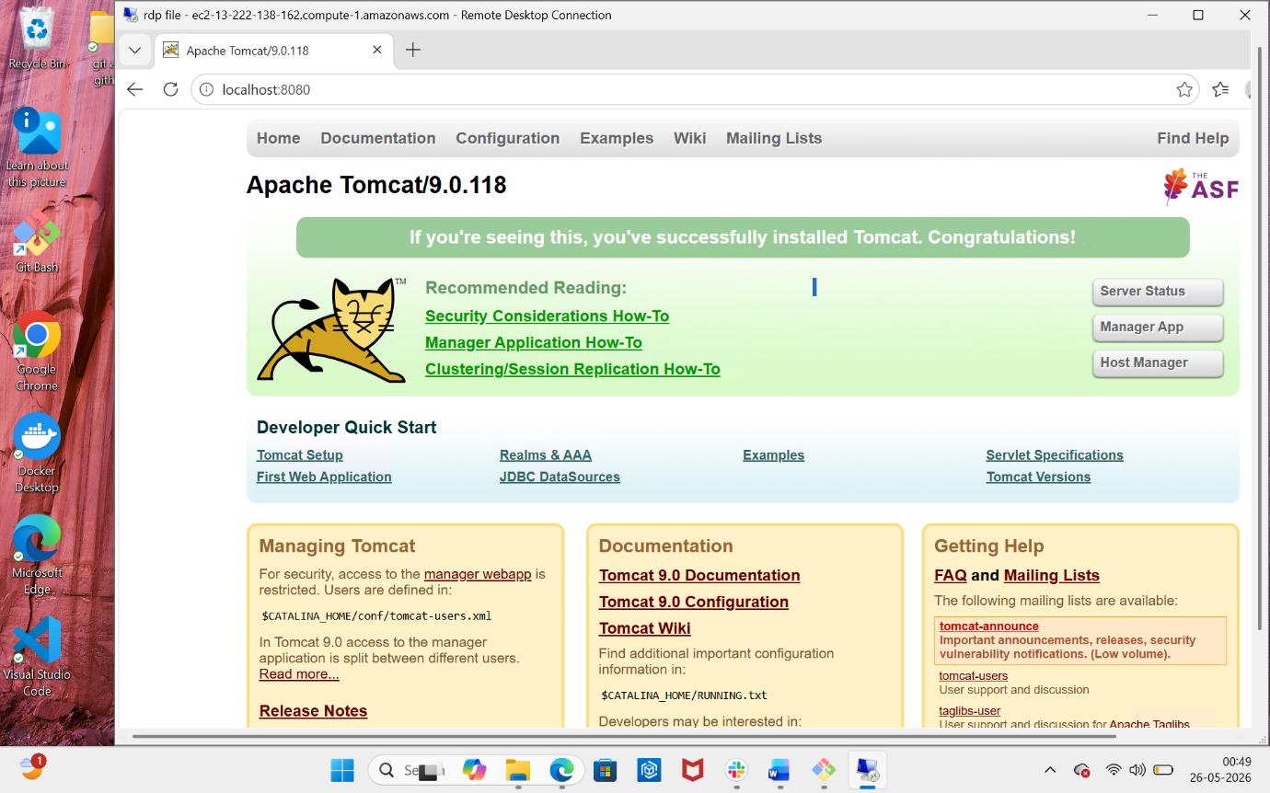

4. Take a snapshot of the instance created in Task 1.
OBJECTIVE: main objective of this task is to took a backup of our server and we can use that snapshot for future use & this snapshot will add to our my amis.
STEP BY STEP IMPLEMENTATION:
- Click on ec2 instance change the state of that instance to running.
- Then click on actions and select image and templates.
- Click on create image to create a snapshot of that ec2 instance.

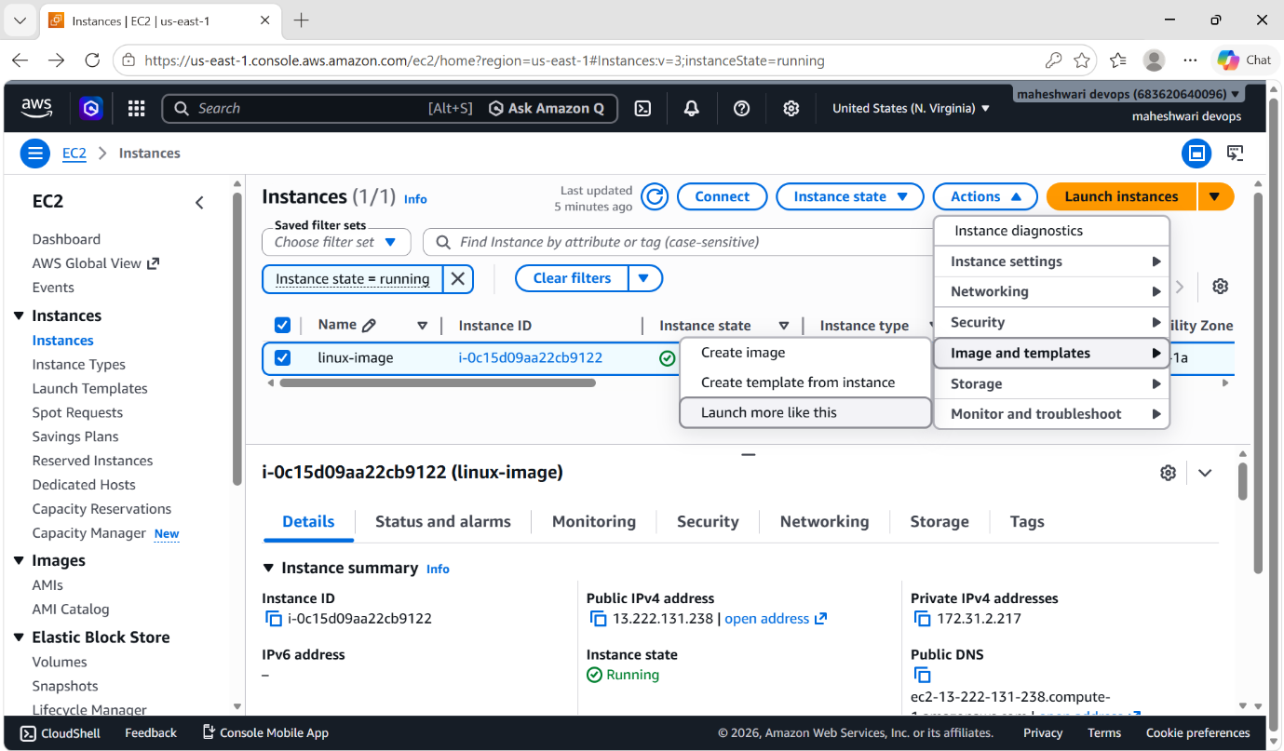

- Then add the image details to that snapshot.

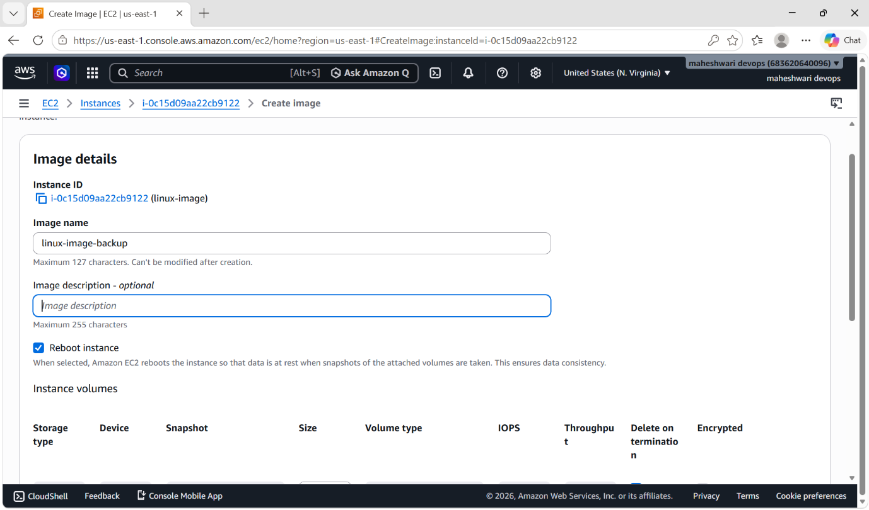

- Click on create an image.

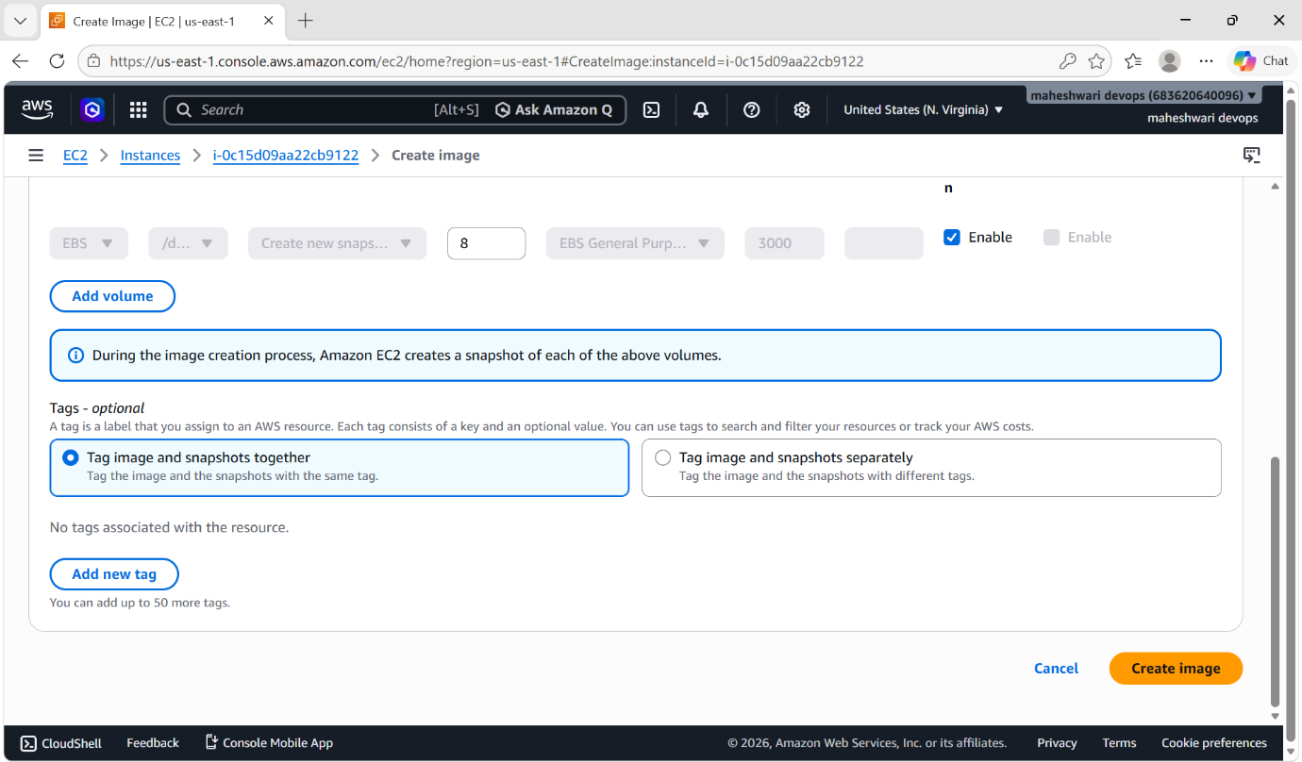

- To verify that created snapshot of our instance, go to ami’s page and u can see that created snapshot.

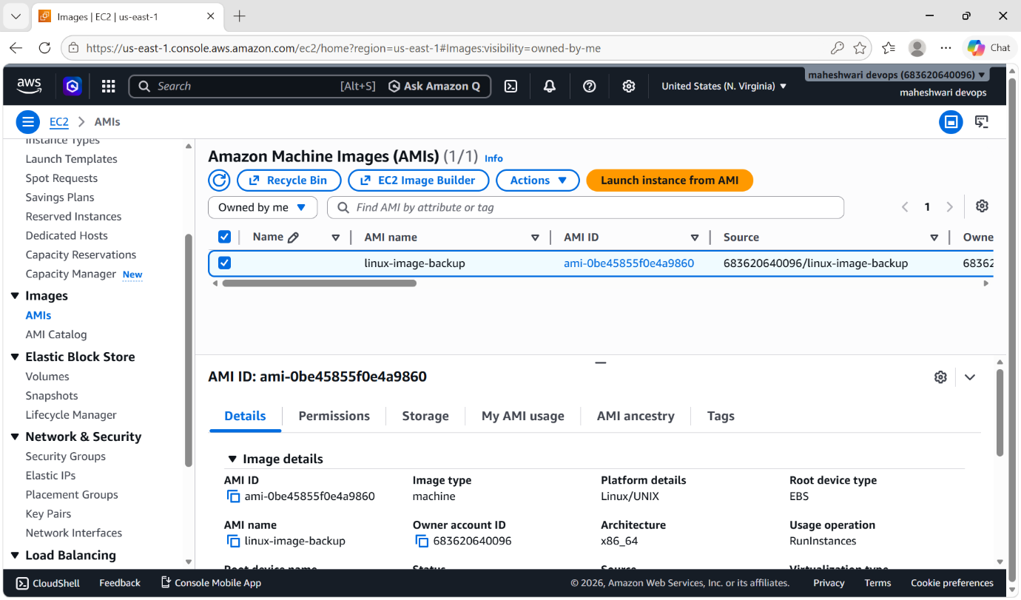

5. Assign passwordless authentication for the EC2 created in Task 2
OBJECTIVE: To login into our server without the pem key

STEP BY STEP IMPLEMENTATION:
- Create a ssh.rsa key in our local machine by using the command -> ssh-keygen
- Then copy that public key that we have generated.
- Now get into that instance where we want to assign password less authentication that is our instance.
- Paste that copied public in the authorized keys file
Vi ~/.ssh/authorized_keys
- Then change the permissions of that file -> chmod 600 ~/.ssh/authorized_keys
- Change the configuration in sshd.config file
- Exit from that instance to check and verify whether the password less authentication is working or not.
- After exiting from the instance try this command -> ssh ubuntu@publicip

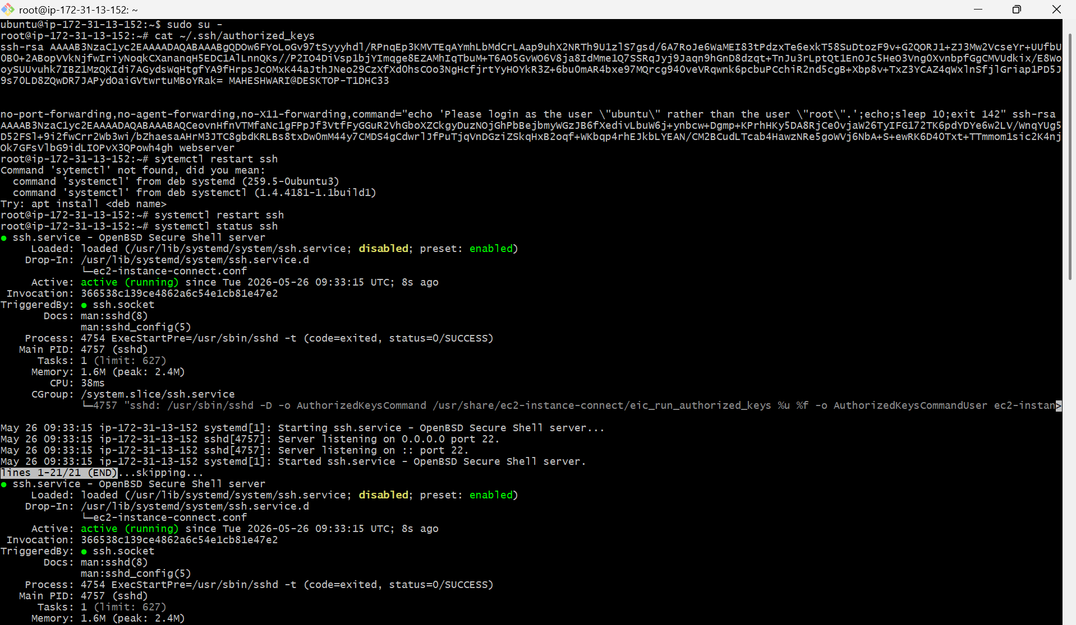

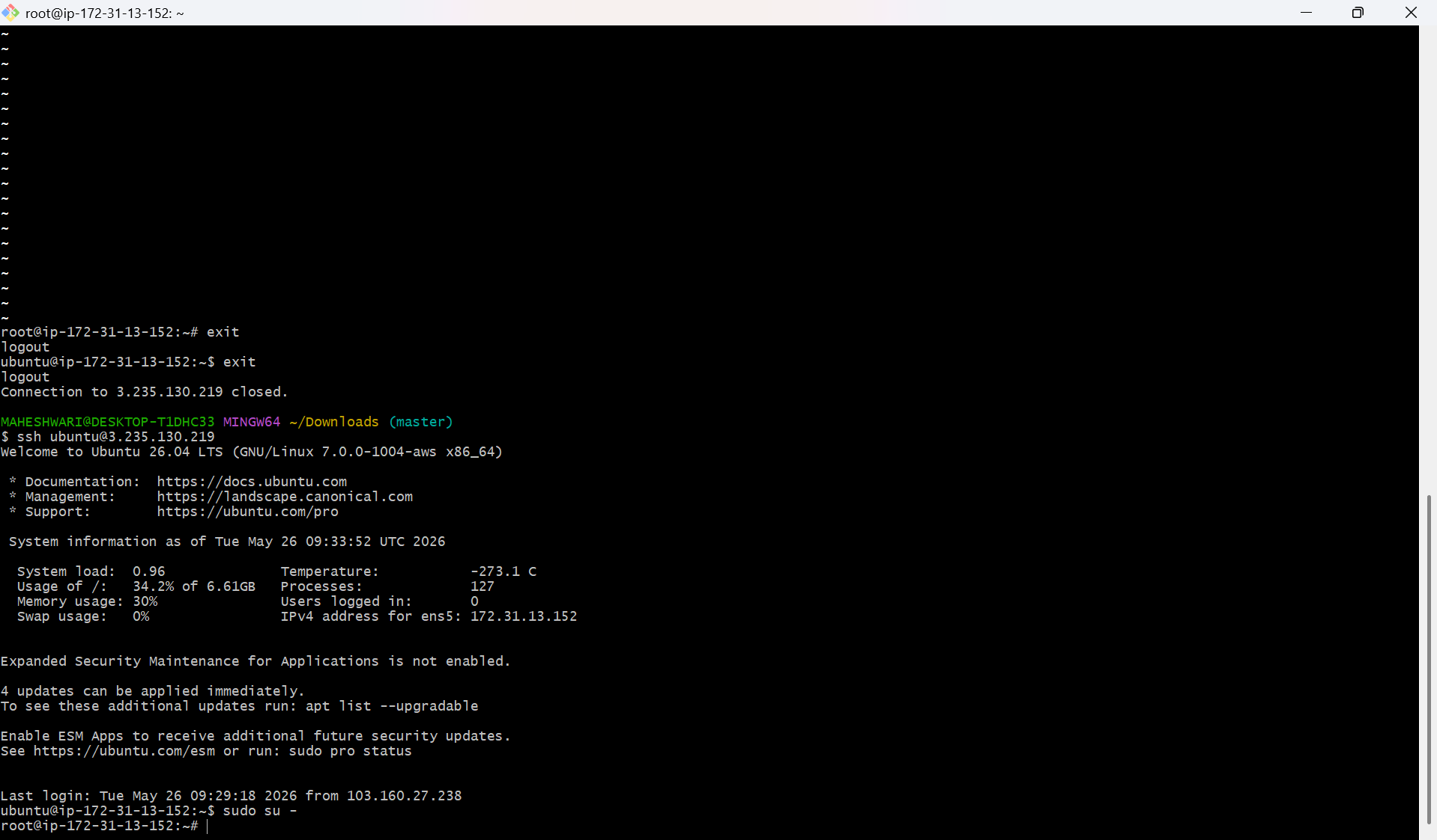

6. Launch any EC2 using the spot purchasing option.
OBJECTIVE: To launch one instance by using spot purchasing option.

STEP BY STEP IMPLEMENTATION:
- Firstly launch one instance and select exixting pem file for login
- Then change the purchasing options -> spot purchasing

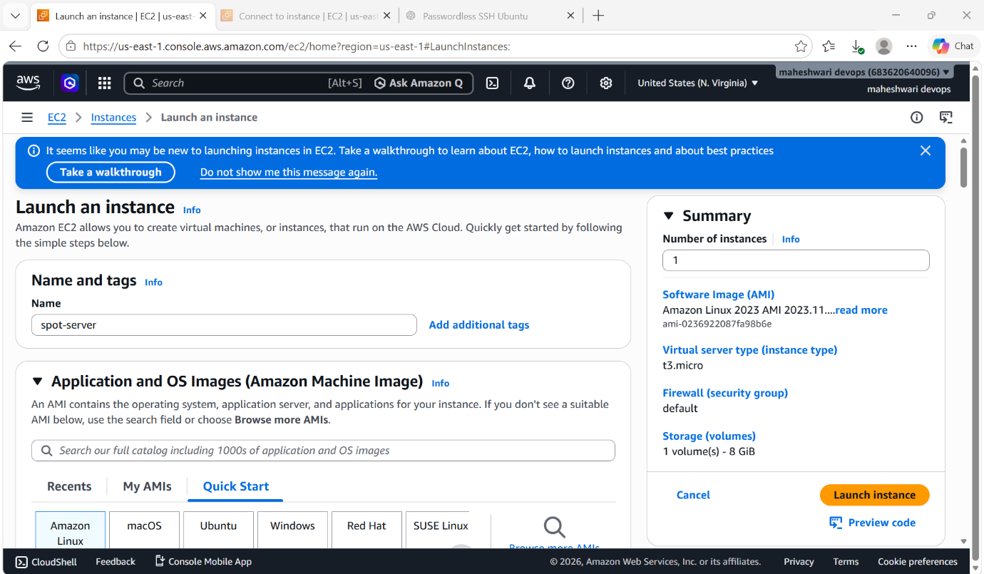

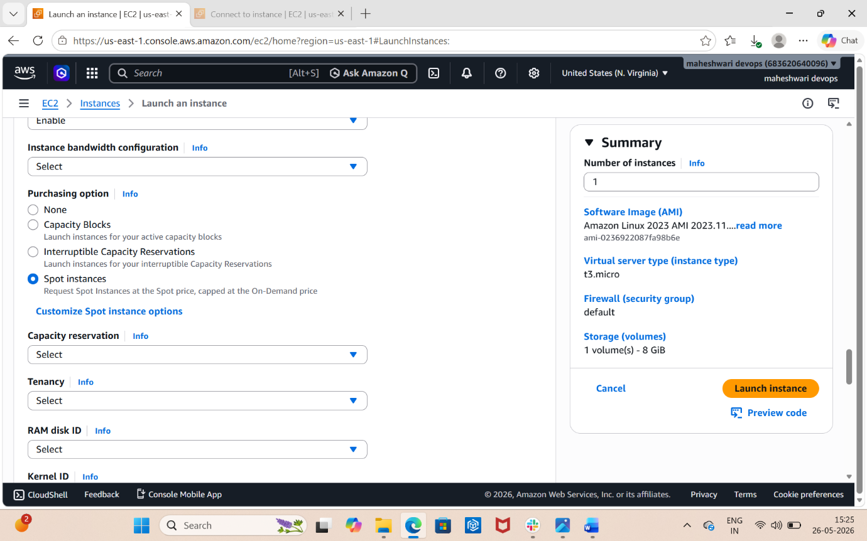

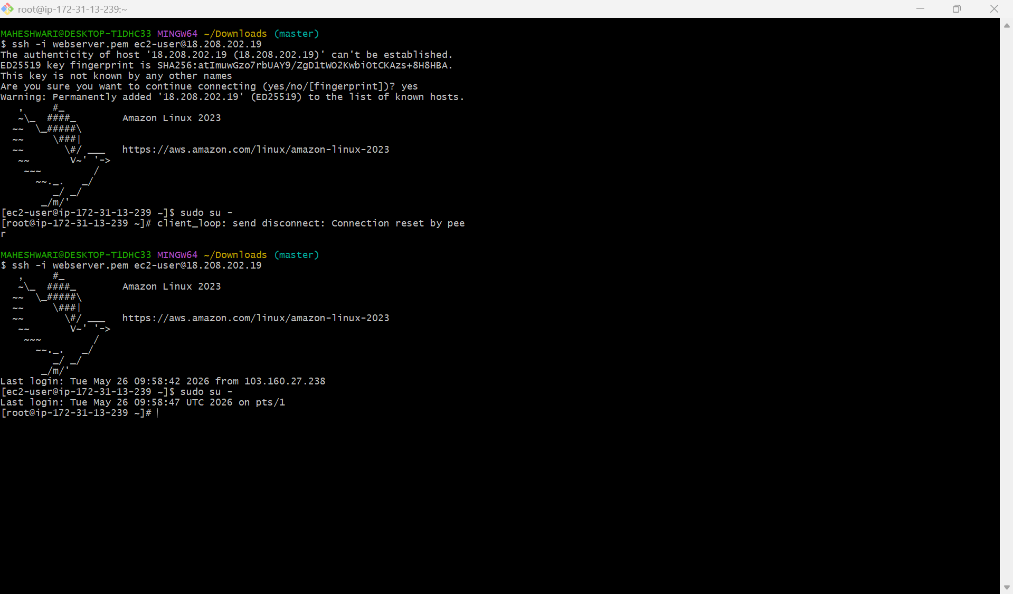

7. Enable termination policy on the EC2 created in Task 2.
OBJECTIVE: by enabling termination policy, we can’t terminate a instance forcefully. We can protect our instance by deleting.
STEP BY STEP IMPLEMENTATION:
- Click on actions on running instance, and select instance settings.
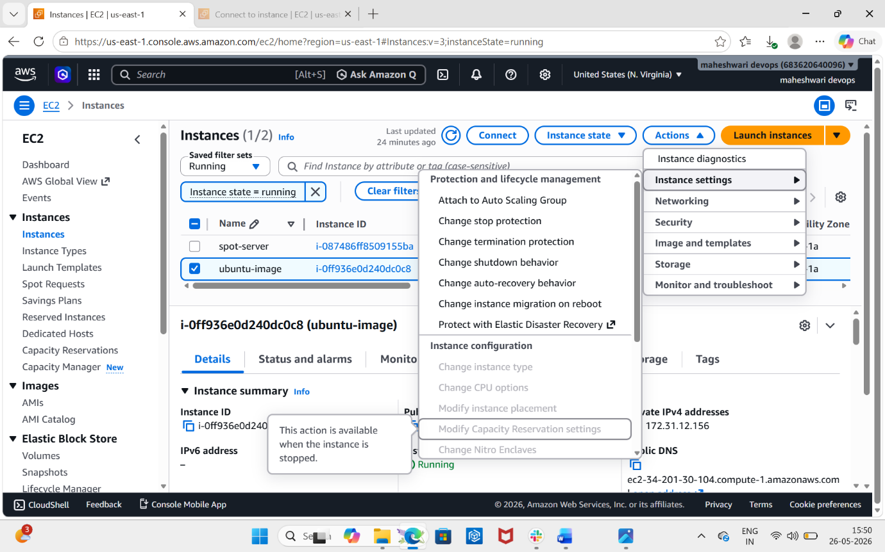
- Then click on change termination protection, it will give a page that to enable the termination protection.
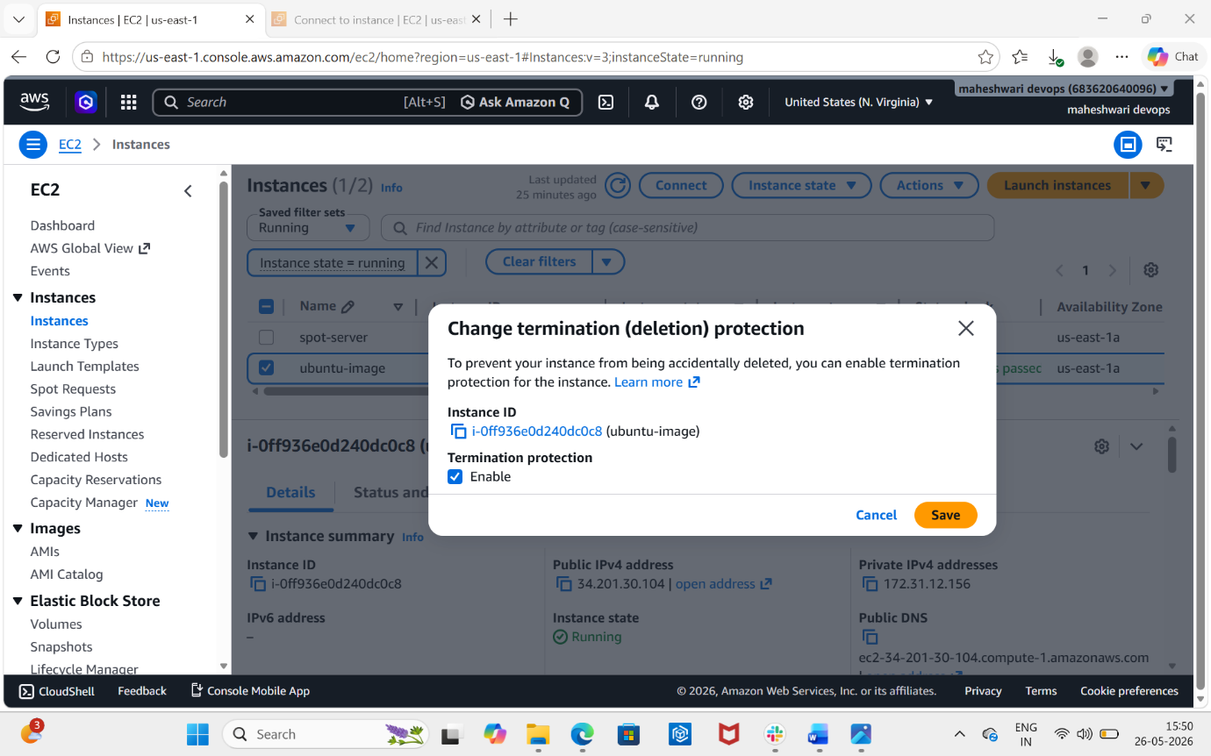
- By enabling this option, we can’t delete the instance forcefully.
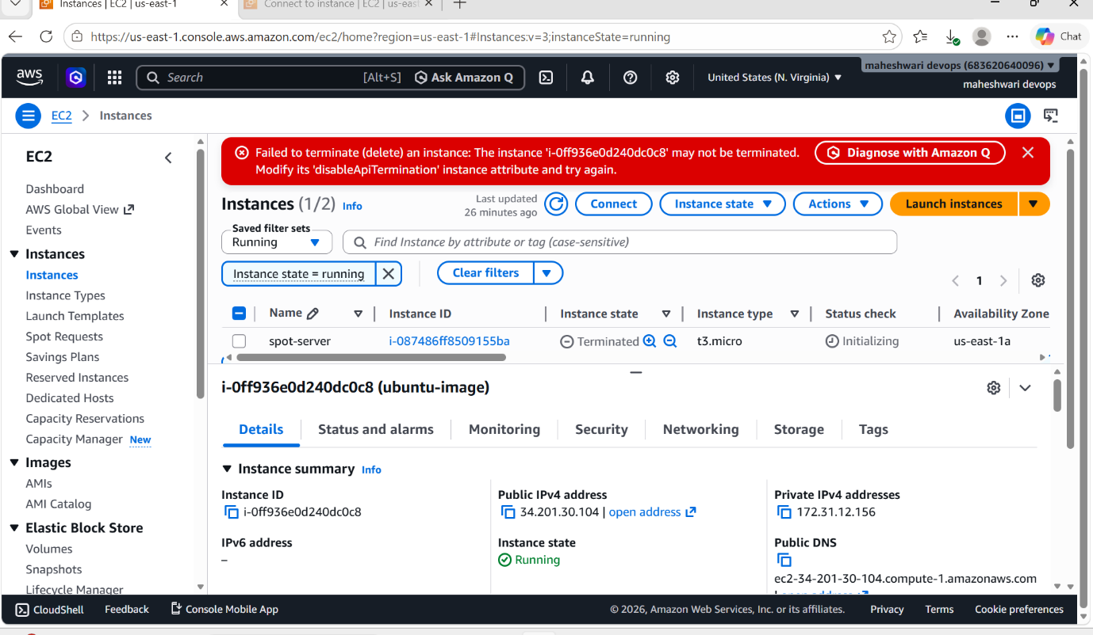

8. Launch one EC2 using AWS CLI.
OBJECTIVE: To run an instance on aws CLI.

STEP BY STEP IMPLEMENTATION:
- Create an iam user and will create security credentials which are used to configure aws cli.

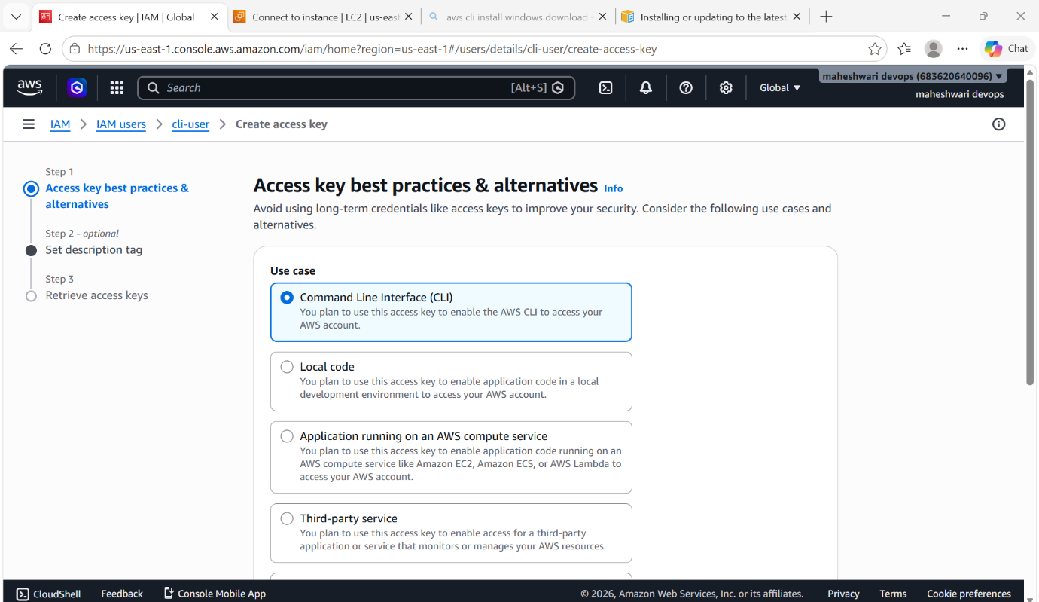

- First of all check for the aws cli in our local manchine in command prompt.
- If aws cli is not downloaded, then download the aws cli from the aws cli install windows.

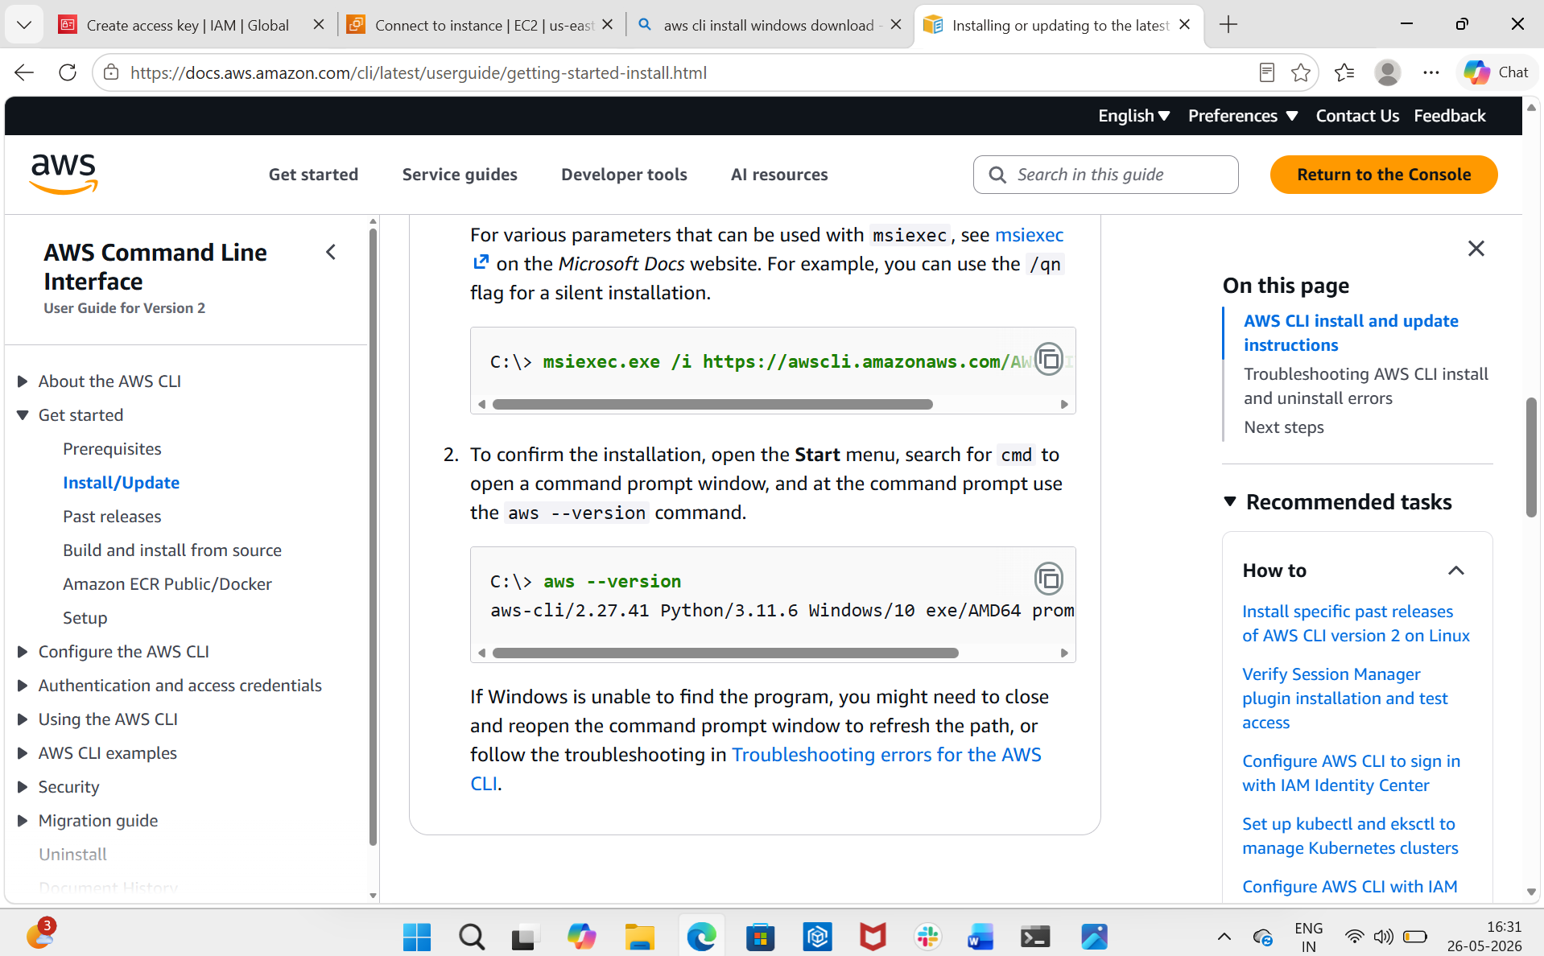

- Then open command prompt of our local machine and search for the aws --version.
- Then configure the aws details -> aws configure
- It will ask for access key and secret access key and format also.

